Oracle Server都裝好了,怎麼 manager in client.
- setup Oracle client
- set net manager of client.
Step1:
Step2:
Hostname | ServerName
Port Number | def 1521. 依Server為依據.
SID | def orcl.依Server為依據.
net Service Name | 依Host值與SID值,自動帶.
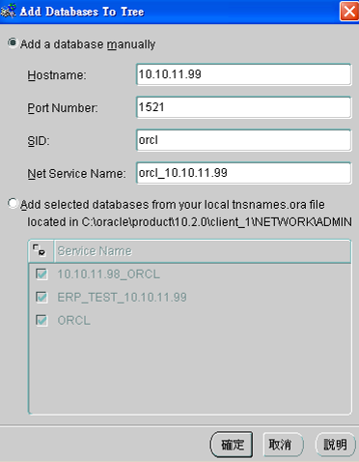
Add Database To Tree設完後,Net Manager自動產生orcl _10.10.11.99.如下:
